SIMATS ENGINEERING

CSA4307
INTERNET PROGRAMMING

ASSESSMENT TOOL 1
Application-Based Questions

C. Dharshini (192311400)

Code of Conduct
I C. Dharshini (192311400) that this submission is my original work and that I have adhered to the guidelines specified for this assessment. I understand that any violation of academic integrity rules will result in disciplinary action.

Signature of the student: C. Dharshini

1. Online Symposium Portal
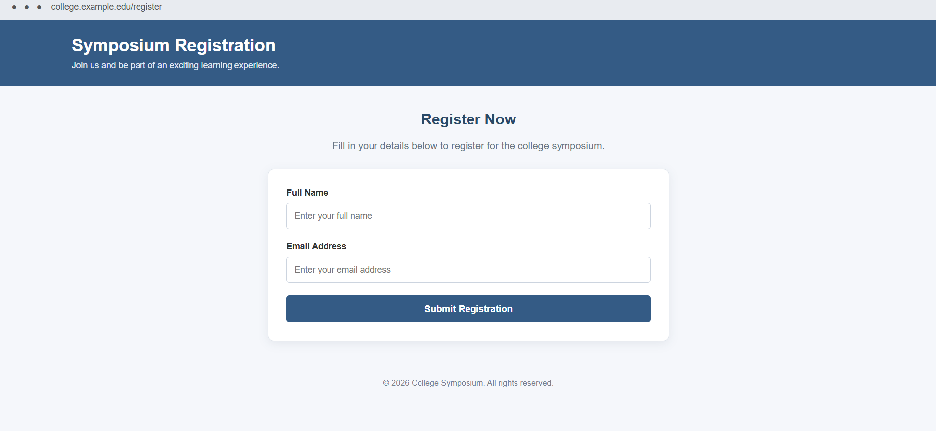
Figure 1: Browser-style view of the corrected Online Symposium Registration page.
The given form allows students to submit their name and email address to the server using the POST method. The form can be improved by adding semantic structure, labels, validation, and a clear HTTP submission flow.

1.1 Identify appropriate HTML5 semantic elements missing in the structure
Answer: The form is not enclosed in meaningful page structure. Depending on the page design, the following semantic elements can be used:
- <header> for the portal title or page heading.
- <main> for the main content of the registration page.
- <section> for the symposium registration area.
- <form> to group the registration controls.
- <footer> for copyright details or contact information.
The <form> element is already present in the given snippet; the main missing semantic structure is around it.

1.2 Modify the structure to make it standards-compliant
A corrected HTML5 example is shown below. Each input has a matching label, a suitable type, and required validation.
<!DOCTYPE html>
<html lang="en">
<head>
<meta charset="UTF-8">
<meta name="viewport" content="width=device-width, initial-scale=1.0">
<title>Symposium Registration</title>
<style>
body {
margin: 0;
font-family: Arial, sans-serif;
color: #333;
}
.browser {
padding: 12px 20px;
background: #eeeeee;
color: #555;
}
header {
background: #345b85;
color: white;
padding: 20px 6%;
}
main {
width: 85%;
max-width: 700px;
margin: 35px auto;
}
form {
padding: 25px;
border: 1px solid #ddd;
border-radius: 6px;
}
label {
display: block;
margin-bottom: 8px;
}
input {
width: 100%;
padding: 11px;
margin-bottom: 18px;
border: 1px solid #ccc;
border-radius: 4px;
box-sizing: border-box;
}
button {
background: #345b85;
color: white;
padding: 11px 20px;
border: none;
border-radius: 4px;
cursor: pointer;
}
footer {
padding: 20px 6%;
color: #666;
}
</style>
</head>
<body>
<div class="browser">college.example.edu/register</div>

<header>
<h1>Symposium Registration</h1>
</header>

<main>
<h2>Register Now</h2>
<p>Enter your details to register for the symposium.</p>

<form action="/register" method="post">
<label for="name">Full Name</label>
<input type="text" id="name" name="name" required>

<label for="email">Email Address</label>
<input type="email" id="email" name="email" required>

<button type="submit">Submit</button>
</form>
</main>

<footer>© 2026 College Symposium</footer>
</body>
</html>

1.3 Interpret the HTTP request generated during form submission
Answer: When the student clicks the submit button, the browser validates the form and sends an HTTP request to the URL specified by action, /register. Because method="post" is used, the request method is POST. The browser sends the named form values in the request body rather than appending them to the URL query string.
A simplified request may look like this:
POST /register HTTP/1.1
Host: example.edu
Content-Type: application/x-www-form-urlencoded
name=Dharshini&email=dharshini%40example.com
The Host header identifies the server, Content-Type describes how the form body is encoded, and the body contains the submitted name-value pairs. Actual headers and values depend on the browser and server.

1.4 Analyze the HTTP response cycle from server to browser
- The browser sends the POST request to the web server.
- The server receives the request, validates the data, and performs the registration operation.
- The server sends an HTTP response containing a status code, response headers, and optionally a response body.
- A successful registration might return 200 OK with a confirmation page, or 303 See Other to redirect the browser to a confirmation page.
- If the submitted data is invalid, the server may return 400 Bad Request and explain the validation errors. If an unexpected server error occurs, it may return 500 Internal Server Error.
- The browser processes the response and displays the confirmation or error message to the student.

1.5 Suggest improvements for usability and accessibility
- Use a visible <label> for every input and connect it using matching for and id attributes.
- Use required and appropriate input types, such as email, to provide basic browser validation.
- Add autocomplete attributes to help users complete the form faster.
- Show clear success and error messages, and preserve entered values when appropriate after validation errors.
- Ensure controls can be reached and operated using a keyboard, with visible focus indicators.
- Use sufficient color contrast, readable text, and a responsive layout for mobile devices.
- Use HTTPS for data transmission and validate all submitted data on the server.

2. Cross-Browser Compatibility Issue
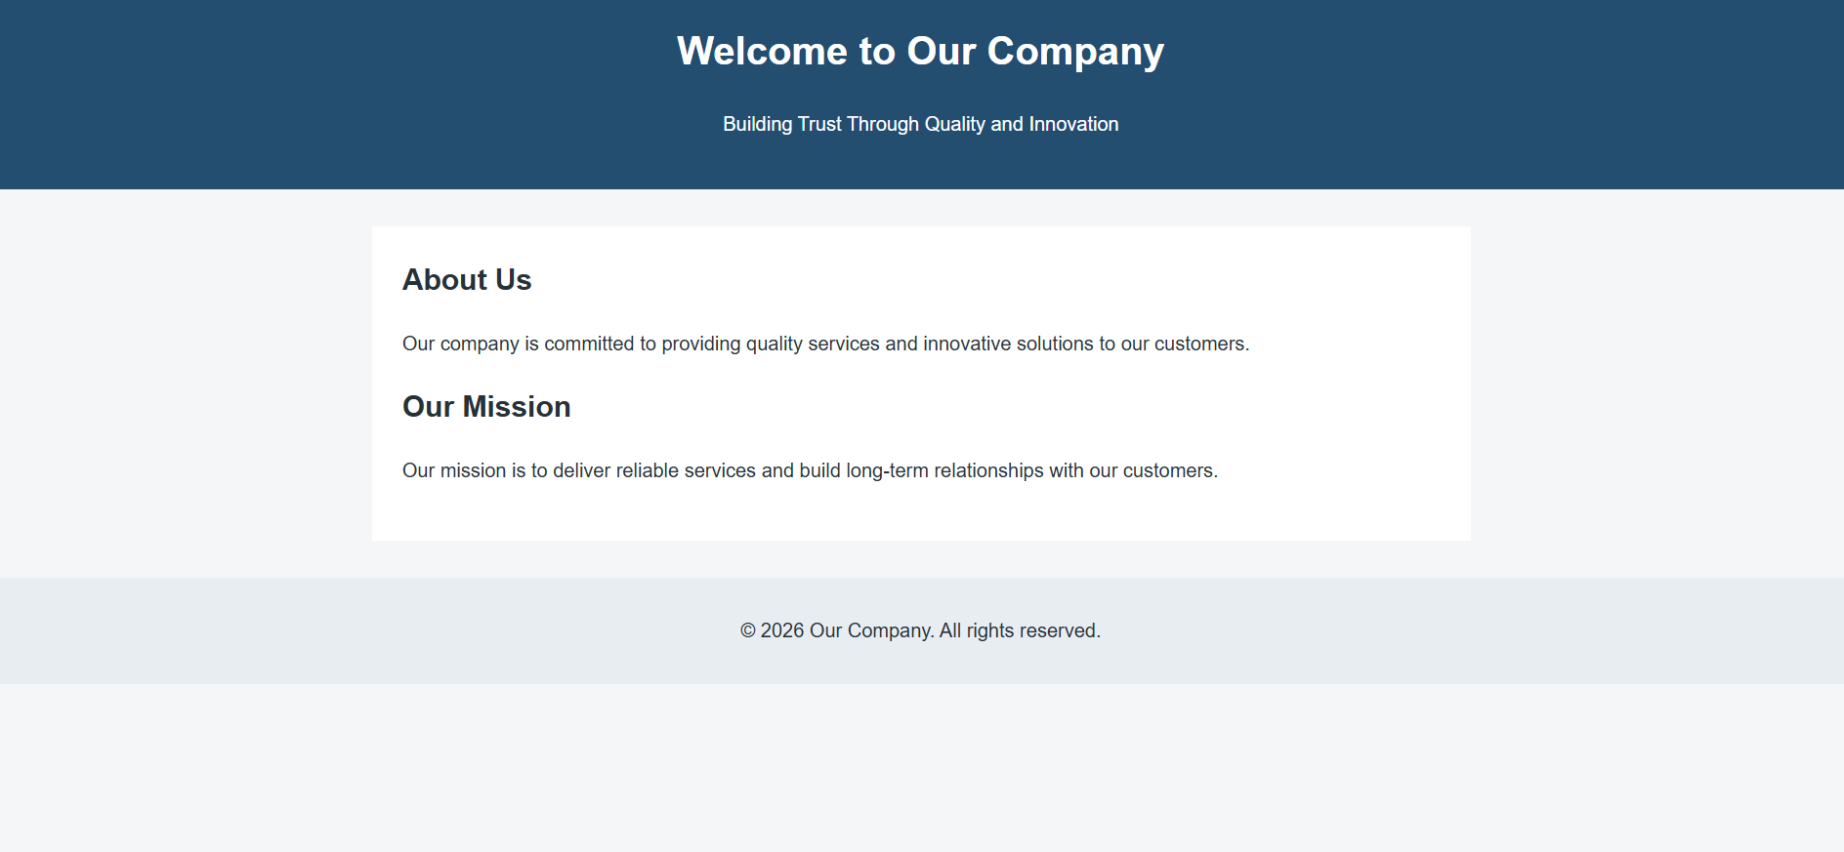
Figure 2: Browser-style view of the corrected semantic Company webpage.
The given HTML contains unclosed heading and paragraph elements and lacks a complete HTML5 document structure. Browsers may attempt to repair malformed markup, but their error recovery and resulting document structure can differ.

2.1 Identify improper nesting and missing closing tags
Answer: The <h1> element is not closed before the <p> element begins, and the <p> element is not explicitly closed. The document also omits <!DOCTYPE html>, the lang attribute, character encoding, and viewport metadata. Although some closing tags can be optional in limited HTML contexts, explicitly closing these elements improves readability and reliability.
<div>
<h1>Welcome</h1>
<p>About us</p>
</div>

2.2 Analyze how different browsers may interpret this structure
Answer: Modern browsers use error-recovery rules to display malformed HTML instead of always stopping. However, the browser may infer where an element ends or construct a DOM tree that differs from what the author intended. This can affect spacing, heading hierarchy, CSS selectors, accessibility-tree output, and JavaScript DOM operations. The exact visual difference depends on the browser and its rendering engine.

2.3 Identify missing semantic elements
Answer: The page would benefit from <header> for the company heading, <main> for the primary page content, <section> for a distinct About Us section, and <footer> for copyright or contact information. Semantic elements communicate the purpose of page regions to browsers, developers, and assistive technologies.

2.4 Provide a corrected W3C-compliant HTML structure

<!DOCTYPE html>
<html lang="en">
<head>
<meta charset="UTF-8">
<meta name="viewport" content="width=device-width, initial-scale=1.0">
<title>Company - About Us</title>

<!-- CSS Reset for consistent browser rendering -->
<style>
* {
box-sizing: border-box;
}

body {
margin: 0;
padding: 0;
font-family: Arial, Helvetica, sans-serif;
line-height: 1.6;
color: #263238;
background-color: #f4f6f8;
}

header {
background-color: #234e70;
color: white;
text-align: center;
padding: 25px;
}

main {
max-width: 900px;
margin: 30px auto;
padding: 25px;
background-color: white;
}

section {
margin-bottom: 20px;
}

h1, h2 {
margin-top: 0;
}

footer {
background-color: #e8edf2;
text-align: center;
padding: 15px;
}

a:focus-visible {
outline: 3px solid #234e70;
outline-offset: 3px;
}

@media (max-width: 600px) {
main {
margin: 15px;
padding: 18px;
}

header {
padding: 18px;
}
}
</style>
</head>

<body>

<!-- Website header -->
<header>
<h1>Welcome to Our Company</h1>
<p>Building Trust Through Quality and Innovation</p>
</header>

<!-- Main content -->
<main>
<section aria-labelledby="about-heading">
<h2 id="about-heading">About Us</h2>
<p>
Our company is committed to providing quality services
and innovative solutions to our customers.
</p>
</section>

<section aria-labelledby="mission-heading">
<h2 id="mission-heading">Our Mission</h2>
<p>
Our mission is to deliver reliable services and build
long-term relationships with our customers.
</p>
</section>
</main>

<!-- Website footer -->
<footer>
<p>&copy; 2026 Our Company. All rights reserved.</p>
</footer>

</body>
</html>
This structure uses valid nesting, explicit closing tags, semantic landmarks, and standard HTML5 metadata.

2.5 Suggest techniques to ensure cross-browser compatibility
- Validate the markup using the W3C Markup Validation Service and fix reported errors.
- Use standards-compliant HTML and CSS, with a correct <!DOCTYPE html> declaration.
- Test the site in major browsers such as Chrome, Firefox, Edge, and Safari, and at different screen sizes.
- Use a CSS reset or normalize stylesheet when appropriate to reduce inconsistent default styling.
- Prefer widely supported features or check compatibility before using newer APIs and CSS properties.
- Use responsive design and feature detection rather than relying on browser-specific assumptions.
- Keep HTML, CSS, and JavaScript organized and test keyboard navigation and accessibility.

3. Form Submission Failure
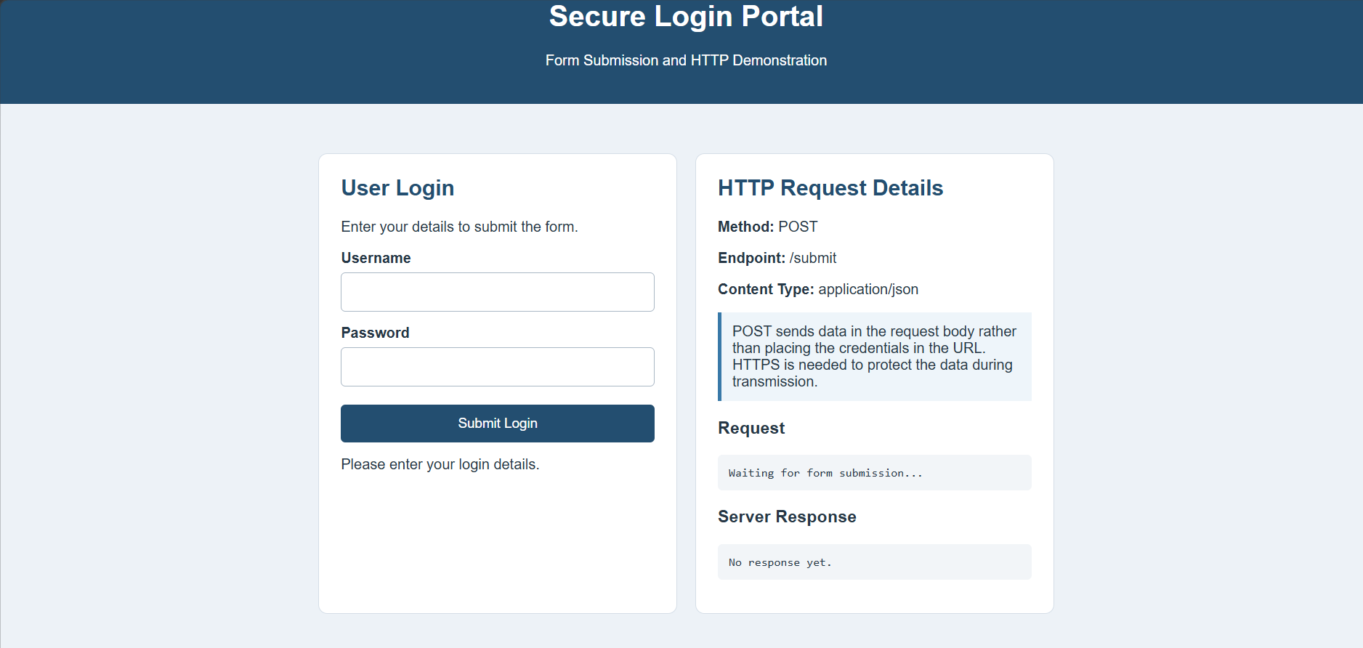
Figure 3: Browser-style view of the corrected Login form.
In the given form, the Login button has type="button". This button does not submit the form by default, which is the main reason no form submission request is triggered when it is clicked.

3.1 Identify issues in the form configuration
- The button uses type="button" instead of type="submit".
- The form uses GET while collecting a password. GET places form values in the URL query string and is unsuitable for credentials.
- The inputs do not have labels or required validation.
- The form has no explicit autocomplete guidance or user-friendly error handling.

3.2 Analyze why the HTTP request is not triggered
Answer: A button with type="button" is a generic button and does not automatically submit its containing form. Unless JavaScript explicitly handles the click and sends a request, clicking Login will not trigger the form's normal submission behavior. Changing the button to type="submit" enables the browser's standard form submission process.

3.3 Interpret the role of GET method in this scenario
Answer: GET is intended mainly for retrieving resources. Form values are appended to the URL as a query string, for example /submit?username=user&password=secret. URLs can be stored in browser history, web server logs, analytics systems, and other places, so passwords must not be sent using GET. GET requests are also commonly cached or bookmarked, making them inappropriate for login credentials.

3.4 Propose a corrected implementation
<!DOCTYPE html>
<html lang="en">
<head>
<meta charset="UTF-8">
<meta name="viewport" content="width=device-width, initial-scale=1.0">
<title>Login Portal</title>
<style>
body {
margin: 0;
font-family: Arial, sans-serif;
color: #333;
}
.browser {
padding: 12px 20px;
background: #eeeeee;
color: #555;
}
header {
background: #46566a;
color: white;
padding: 20px 6%;
}
main {
width: 85%;
max-width: 500px;
margin: 35px auto;
}
form {
padding: 25px;
border: 1px solid #ddd;
border-radius: 6px;
}
label {
display: block;
margin-bottom: 8px;
}
input {
width: 100%;
padding: 11px;
margin-bottom: 18px;
border: 1px solid #ccc;
border-radius: 4px;
box-sizing: border-box;
}
button {
background: #46566a;
color: white;
padding: 11px 22px;
border: none;
border-radius: 4px;
cursor: pointer;
}
.note {
color: #666;
font-size: 13px;
}
</style>
</head>
<body>
<div class="browser">college.example.edu/login</div>

<header>
<h1>Account Portal</h1>
</header>

<main>
<h2>Login</h2>
<p>Enter your credentials to continue.</p>

<form action="/submit" method="post">
<label for="username">Username</label>
<input type="text" id="username" name="username"
autocomplete="username" required>

<label for="password">Password</label>
<input type="password" id="password" name="password"
autocomplete="current-password" required>

<button type="submit">Login</button>

<p class="note">Keep your password private.</p>
</form>
</main>
</body>
</html>
The submit button now triggers normal form submission, and POST sends the form fields in the request body. This does not by itself encrypt the data; HTTPS is still required.

3.5 Suggest improvements for secure data transmission
- Use HTTPS (TLS) for the entire login process so credentials are encrypted in transit.
- Submit credentials using POST rather than GET; remember that POST alone does not provide encryption.
- Validate input on the server and use secure password-hashing practices for stored passwords.
- Avoid logging passwords or exposing them in error messages, URLs, or analytics.
- Use secure session management, including HttpOnly and Secure cookie attributes where appropriate.
- Apply rate limiting and other protections against repeated login attempts, and provide generic authentication error messages.
- Keep dependencies and server software updated and configure security headers appropriately.

Conclusion
Well-structured HTML improves consistency, accessibility, and maintainability. Correct form methods and button types ensure that browser submissions work as intended. HTTP status codes and response bodies communicate the result to the browser, while HTTPS and sound server-side validation help protect submitted information.

